# Approval

|  |  |  |  |
| --- | --- | --- | --- |
| **Name** | **Function** | **Date** | **Signature** |
| Georgio Mosis |  |  |  |
|  |  |  |  |

# Revision History

| **Date** | **Revision number** | **Status** | **Author** | **CR/PR ID** | **Changes/Comments** |
| --- | --- | --- | --- | --- | --- |
| 2015-04-13 | 0.1 | draft | Kevin Song |  | Initial CCS System SRS document |
| 2015-04-17 | 0.2 | Draft | Kevin Song |  | Update requirement analysis for Discharge part |
|  |  |  |  |  |  |
|  |  |  |  |  |  |

# Open Issues

The following open issues are identified:

| **Id** | **Category** | **Issue** | **Owner** | **Due date** |
| --- | --- | --- | --- | --- |
|  |  |  |  |  |

# Table of Contents

Approval 1

Revision History 1

Open Issues 1

1. Table of Contents 2

2. Document Introduction 2

2.1. Purpose and Scope 2

2.2. Intended Audience 2

2.3. References 3

2.4. Definitions, Acronyms and Abbreviations 3

3. Product Overview 3

3.1. Purpose and Intended Use 3

3.2. System Description 3

3.3. Network Security 5

4. Context Analysis 5

5. Functionality 6

5.1. Frequently used functions 6

6. Software Requirements 6

Functional and Capability Requirements 6

Software System Inputs and Outputs 15

Interfaces 15

Software-driven Alarms, Warnings, and Operator Messages 15

Security and Privacy Requirements 15

Usability Engineering Requirements 15

Data Definition and/or Database Requirements 16

Installation and Acceptance Requirements 18

Methods of Operation 18

Maintainability and Upgradeability 18

User Documentation 18

User Maintenance Requirements 18

Regulatory Requirements 18

Risk Control Measures 18

7. Traceability Matrix 19

# Document Introduction

## Purpose and Scope

This SRS document describes all of the requirement specifications for CCS System.

## Intended Audience

This SRS document is intended for various kinds of readers who are going to work or use the system, including customer representatives, project managers, architects, analysts, designers, developers, testers, etc.

## References

|  |  |  |
| --- | --- | --- |
| **Reference** | **Identification** | **Title / additional remarks** |
|  |  |  |
|  |  |  |
|  |  |  |
|  |  |  |

## Definitions, Acronyms and Abbreviations

|  |  |
| --- | --- |
| **Term** | **Description** |
| CCS | Cardiovascular Care Solution |
| CDR | Clinic Data Repository |
| PKU1 | Peking University No1 Hospital |
| SRS | System Requirement Specification |
|  |  |

# Product Overview

## Purpose and Intended Use

CCS System is a comprehensive solution for cardiovascular patients; it could help patients, nurses and physicians to manage the whole post-hospitalization process to track and treat cardiovascular disease.

## System Description

CCS System is a business flow system used for patient post-hospitalization management for cardiovascular disease.

It is mostly a C/S style system with a centric Backend Server running in Ali Cloud and Android Application running in Android Tablets; besides above parts, there is also a Data Server running in PKU1 to acquire or share patient data with PKU1 Systems.

CCS System will involve about 200 total users and less than 50 users for concurrent access.

CCS System will store data in Ali Cloud for Backend Server access only.

CCS System will provide Chinese version presentation only.

CCS Android Application will adopt resolution of 1280*800 for landscape orientation only.

Please refer to below diagram for High Level Architecture:

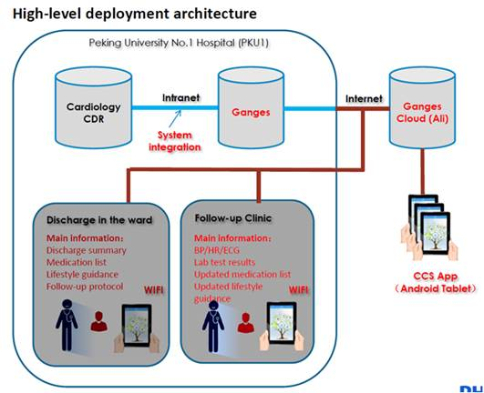

Here are some Technical Constraints/Concerns for the Architecture from PKU1 due to privacy/security considerations:

* Define and implement proper privacy policy for the CCS System
* CCS Cloud Server will deploy on Ali Cloud within internet, need guarantee both application and data privacy/security
* CCS Data Server will deploy in PKU1 intranet for data transmission between CDR and CCS Servers, it can just connect to CCS Cloud Server within internet, and can just be called by CDR system within intranet(can`t connect to any other Systems within PKU1 intranet), controlled by PKU1 IT
* Applications(Android Application, Java Web System) will connect to CCS Cloud Server within internet directly

Please be noted that purple Actors or Use Cases in below UML diagrams are actually not in CCS System scope.

There are multi-roles in the whole process, each of them will have different permissions to take different operations; please refer to below diagram for roles and the hierarchy:

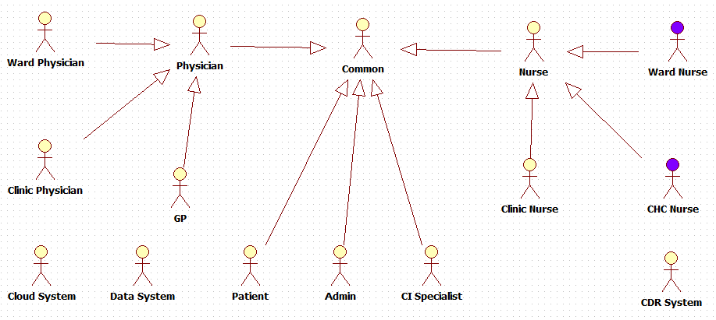

High Level Use Cases, please refer to below diagram:

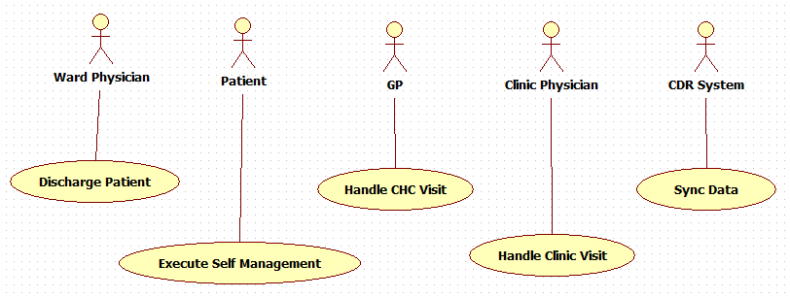

There are different activities executed successively in different areas, please refer to below diagram for the whole business workflow:

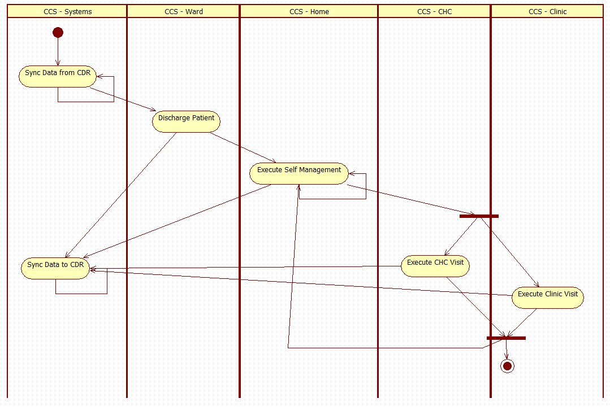

Will describe the details in Ch. 6.

## Network Security

Network security strategy should be defined to protect application security and patient data privacy.

* PKU1 IT will control CCS Data Server and CCS Cloud Server connectivity with PKU1 intranet and Systems
* CCS System will adopt Ali Cloud security services to protect system security
* CCS System will adopt TLS + AES for data transport on network
* CCS System will adopt token check and authentication way for requests access
* CCS System will adopt authentication way for resources access
* Android Application will restrict permissions to protect application security

# Context Analysis

CCS System is not a standalone system, it will integrate with PKU1 CDR System for Patient Data acquiring and sharing; meanwhile CCS System modules will deploy separately on both internet and intranet, PKU1 IT will control the connectivity and access permissions.

Please refer below High Level Architecture Diagram and refer to Ch. 3.2 for details.



# Functionality

<Functionality>

Describe or reference primary operating functions, frequent and worst-case use scenarios in the form of use cases or user stories. Also list the exceptional use cases for foreseeable use errors.

## Frequently used functions

If the legal manufacturer is required, by IEC 62366 or by the applicable QMS (e.g. of Philips Healthcare), to provide a Usability Engineering File [UEF], make a list of frequently used functions. Note that this will make this subsection part of the [UEF]. Also, an annex to this SwRS can be added that contains a matrix that relates the frequently used functions to the relevant software requirements from section 6.

If not applicable, this subsection may be removed.

# Software Requirements

CCS System is a comprehensive solution for cardiovascular patients; it could help patients, nurses and physicians to manage the whole post-hospitalization process to track and treat cardiovascular disease.

## Functional and Capability Requirements

There are 7 scenarios/modules regarding to the whole process, will describe each in detail.

Will not describe requirement details for input/process/output/exception, use screenshots instead.

#### Scenario 1: Common Functions

##### Description:

List common requirements for all users.

##### Requirements List:

|  |  |  |  |
| --- | --- | --- | --- |
| No. | Requirements | Description | Remark |
| R1-01 | User Login Application |  |  |
| R1-02 | User Logout Application |  |  |
| R1-03 | App Loading Progress - Splash Page |  |  |
| R1-04 | User Enter Home Page | Authorization Control |  |
| R1-05 | User Edit Profile |  |  |
| R1-06 | User Edit Settings |  |  |
|  |  |  |  |

##### Use Case Diagram:

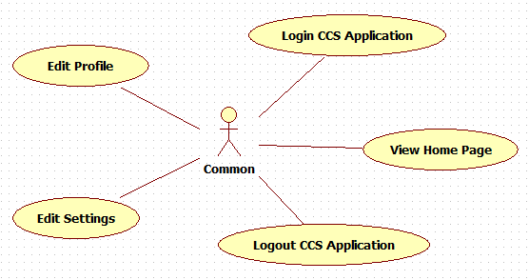

##### Activity Diagram:

N/A

##### Screenshots:

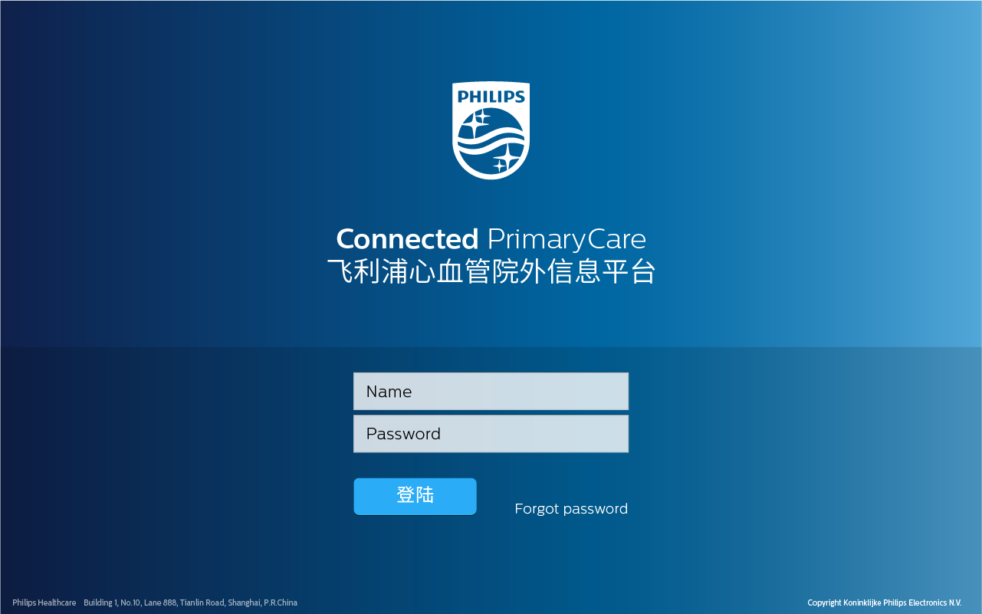

Login Page

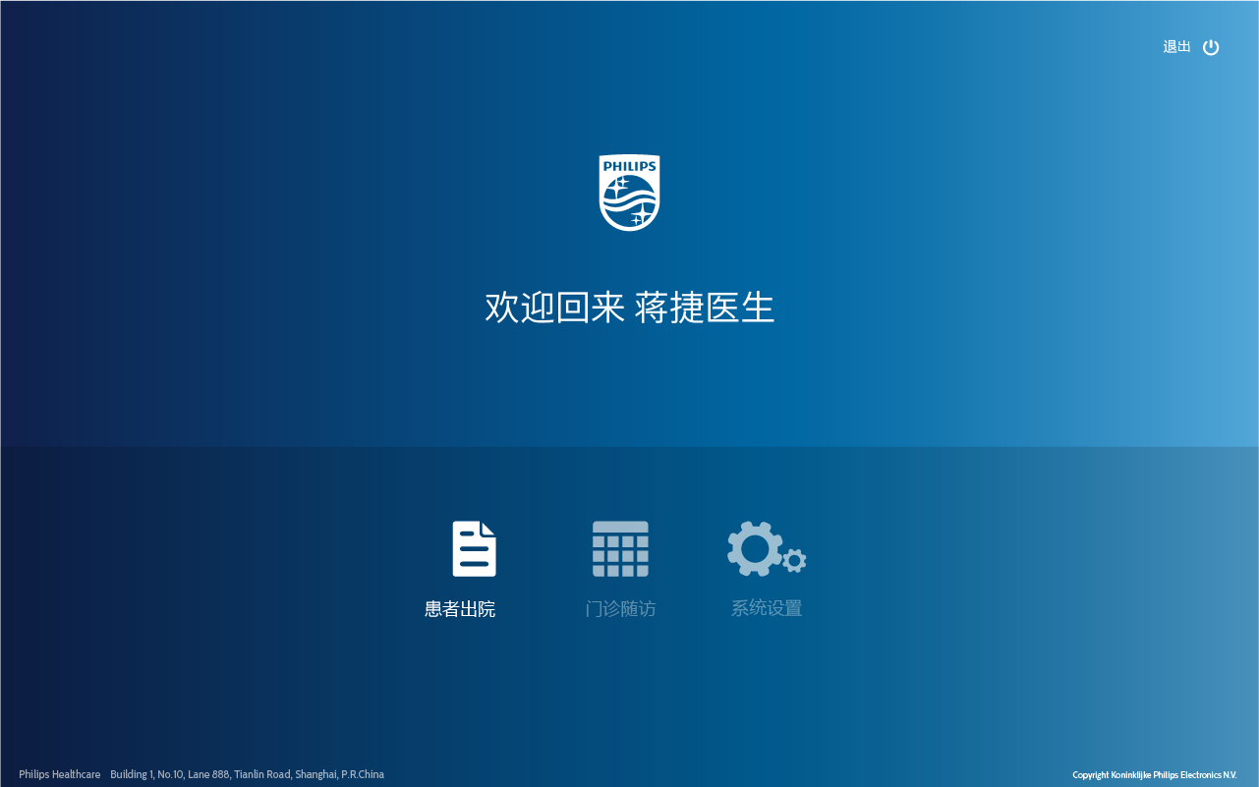

Home Page

#### Scenario 2: Discharge in Ward

##### Description:

List major requirements for discharging patients in Ward.

Patient status strategy: Synced, Involved, Planned, Quitted

##### Requirements List:

|  |  |  |  |
| --- | --- | --- | --- |
| No. | Requirements | Description | Remark |
| R2-01 | Browse Patient List |  |  |
|  |  |  |  |
|  |  |  |  |
|  |  |  |  |
|  |  |  |  |

##### Use Case Diagram:

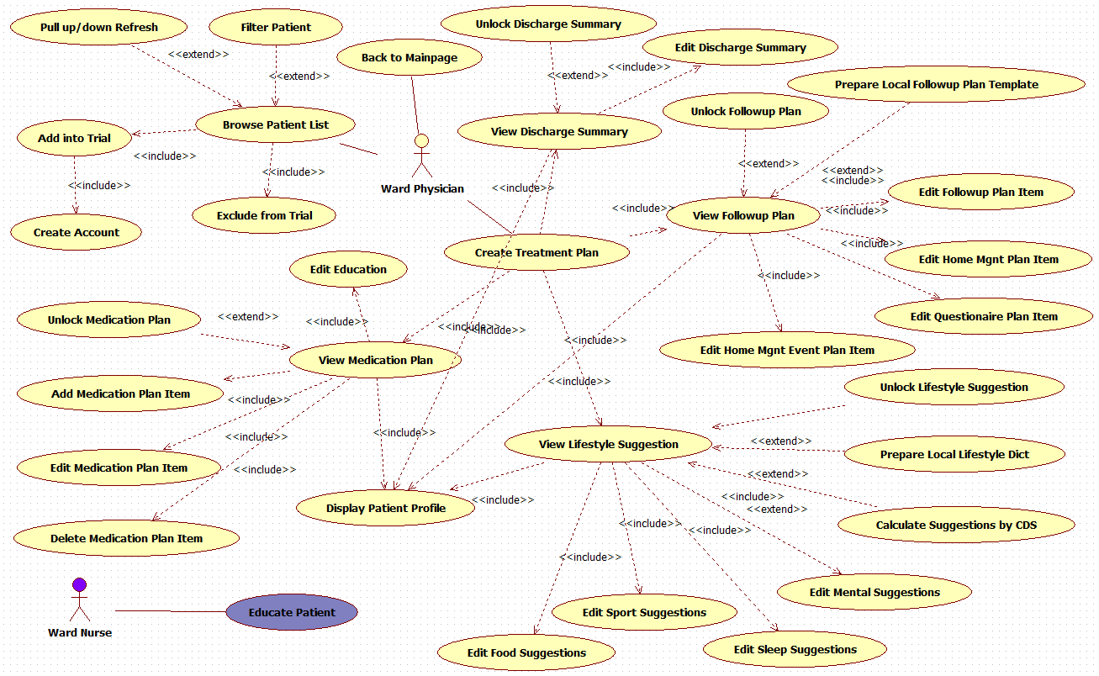

##### Activity Diagram:

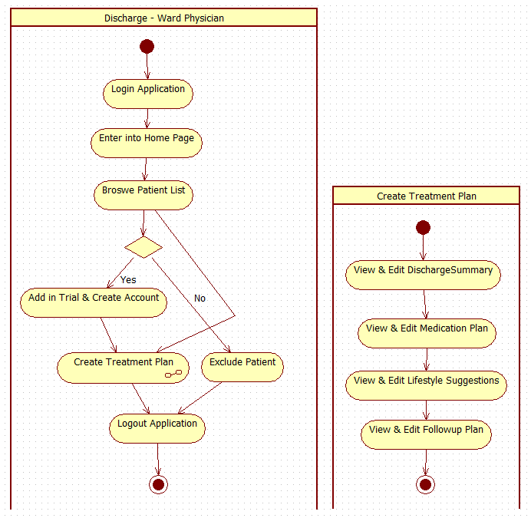

##### Screenshots:

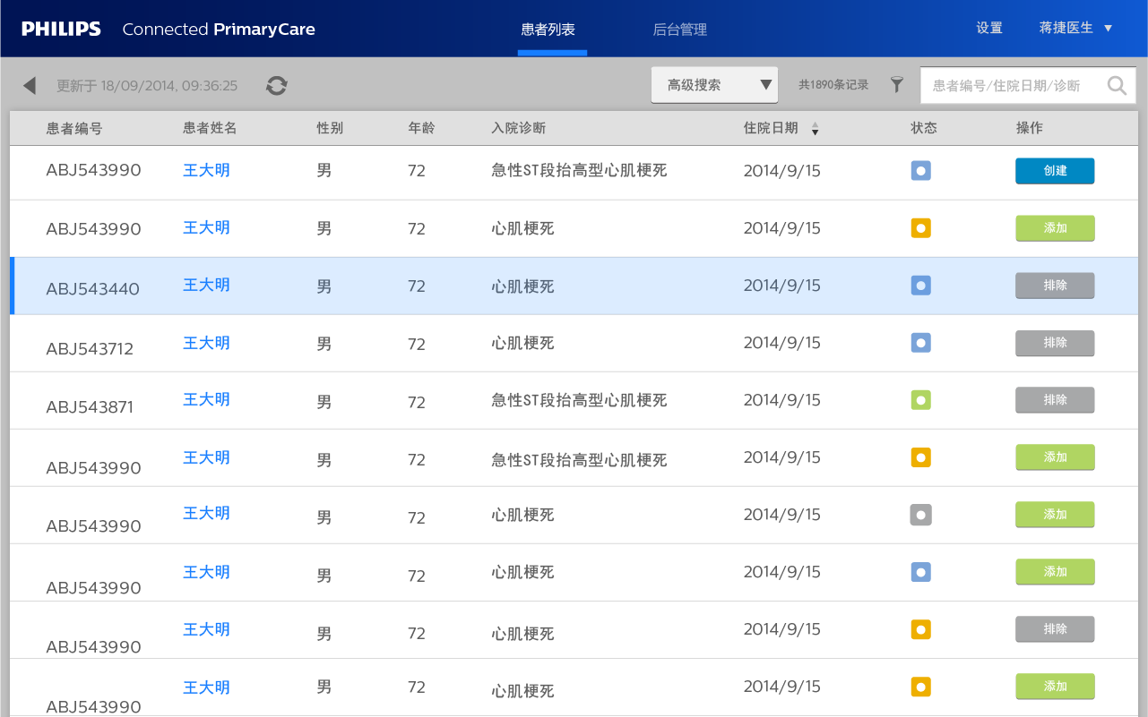

Patient List Page

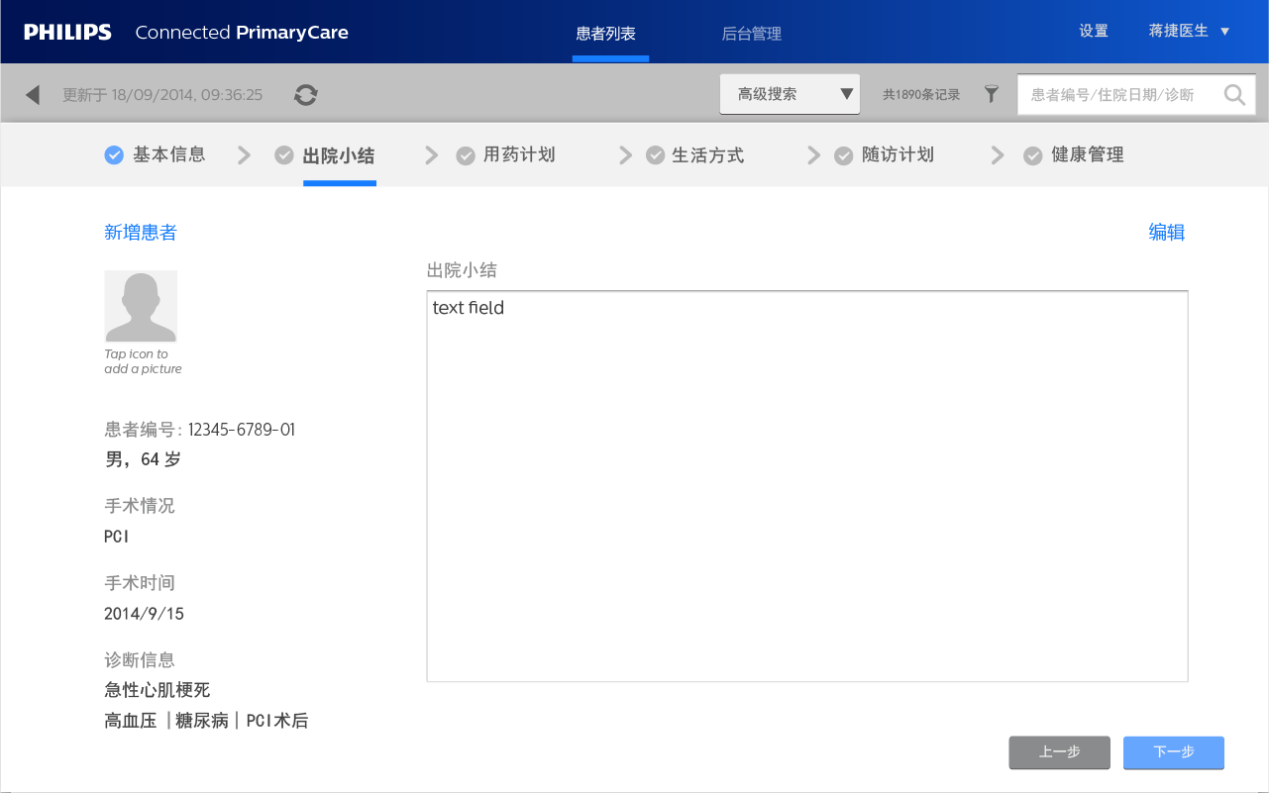

Discharge Summary Page

#### Scenario 3: Home Management

##### Description:

List major requirements for home management for Patients.

##### Requirements List:

|  |  |  |  |
| --- | --- | --- | --- |
| No. | Requirements | Description | Remark |
|  |  |  |  |
|  |  |  |  |
|  |  |  |  |
|  |  |  |  |
|  |  |  |  |

##### Use Case Diagram:

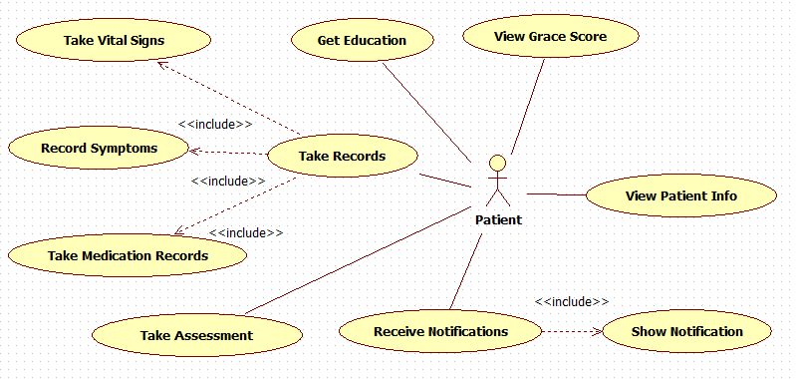

##### Activity Diagram:

N/A

##### Screenshots:

TBD

#### Scenario 4: Follow-up Visit in CHC

##### Description:

List major requirements for follow-up visit in CHC.

##### Requirements List:

|  |  |  |  |
| --- | --- | --- | --- |
| No. | Requirements | Description | Remark |
|  |  |  |  |
|  |  |  |  |
|  |  |  |  |
|  |  |  |  |
|  |  |  |  |

##### Use Case Diagram:

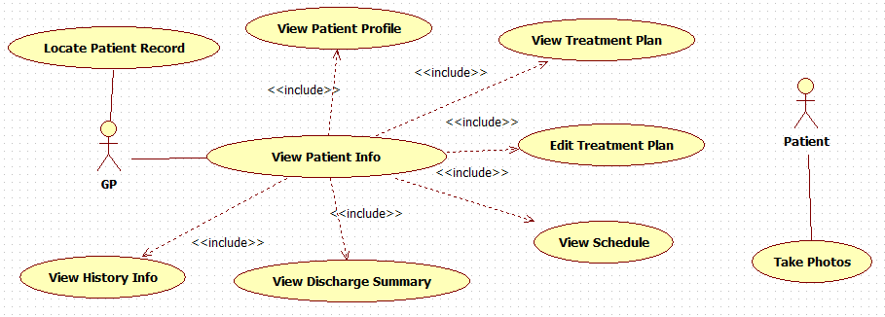

##### Activity Diagram:

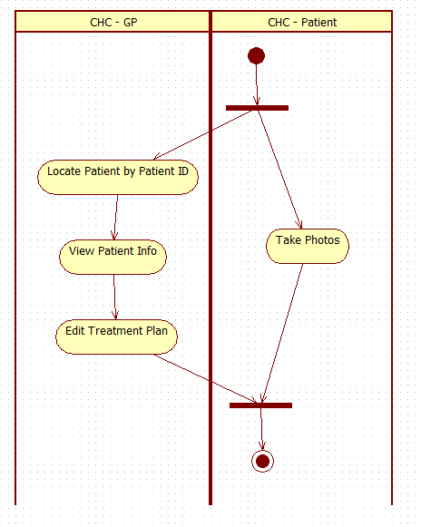

##### Screenshots:

TBD

#### Scenario 5: Follow-up Visit in Clinic

##### Description:

List major requirements for follow-up visit in Clinic.

##### Requirements List:

|  |  |  |  |
| --- | --- | --- | --- |
| No. | Requirements | Description | Remark |
|  |  |  |  |
|  |  |  |  |
|  |  |  |  |
|  |  |  |  |
|  |  |  |  |

##### Use Case Diagram:

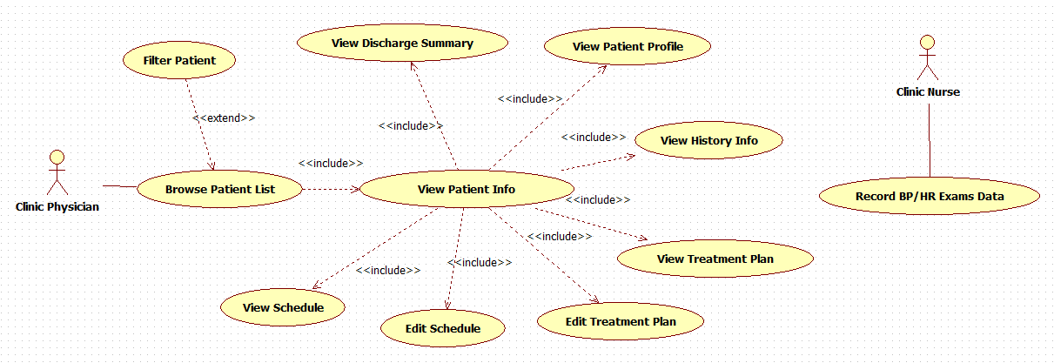

##### Activity Diagram:

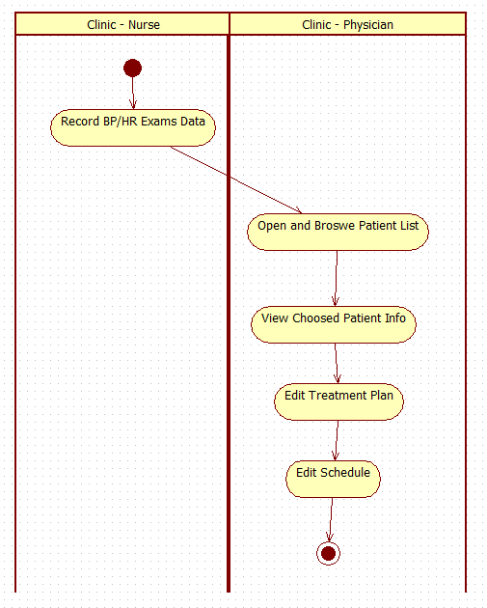

##### Screenshots:

TBD

#### Scenario 6: Data Sync between CDR and CCS Servers

##### Description:

List major requirements for Data sync between Systems.

##### Requirements List:

|  |  |  |  |
| --- | --- | --- | --- |
| No. | Requirements | Description | Remark |
|  |  |  |  |
|  |  |  |  |
|  |  |  |  |
|  |  |  |  |
|  |  |  |  |

##### Use Case Diagram:

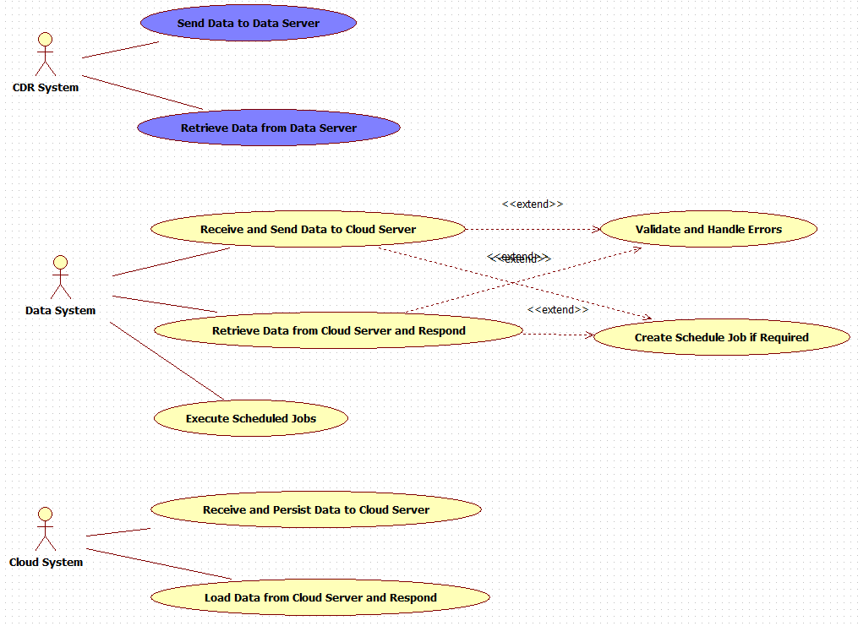

##### Activity Diagram:

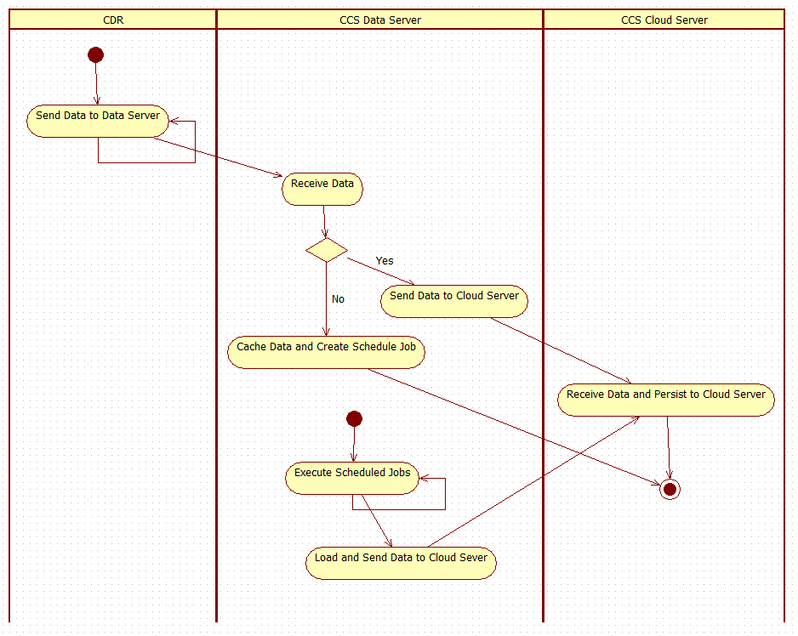

##### Screenshots:

TBD

#### Scenario 7: Management Portal

##### Description:

List major requirements for management portal.

##### Requirements List:

|  |  |  |  |
| --- | --- | --- | --- |
| No. | Requirements | Description | Remark |
|  |  |  |  |
|  |  |  |  |
|  |  |  |  |
|  |  |  |  |
|  |  |  |  |

##### Use Case Diagram:

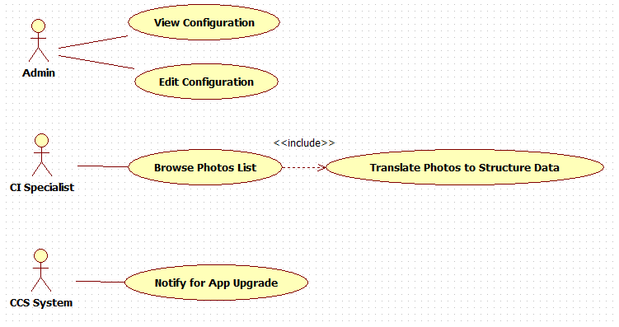

##### Activity Diagram:

N/A

##### Screenshots:

TBD

## Software System Inputs and Outputs

N/A

## Interfaces

TBD, will co-design with CDR team.

## Software-driven Alarms, Warnings, and Operator Messages

N/A

## Security and Privacy Requirements

TBD

## Usability Engineering Requirements

This paragraph deals with requirements that are sensitive to human errors and training. Examples include requirements related to:

* support for manual operations,
* human-equipment interactions,
* constraints on personnel, and
* areas needing concentrated human attention.

## Data Definition and/or Database Requirements

CCS System will use NoSQL Database named Mongo DB as centric Database in Backend Server.

Mongo DB has couple of merits for high concurrency and big data processing scenarios.

When design Data Model, need take below items into consideration:

* Deployment or scaling strategy
  + Adopt standalone deployment
* Though no Schema is a big merit for NoSQL, but let`s make each Document with fixed schema
* Embedded document or reference document
  + Adopt manual reference for most of documents, only simple document will be embedded into other Document
  + The manual reference normally named as “xxxid” in the Document
* Document Indexes strategy
  + Create proper indexes for important where-condition or classification fields
* Operational transaction strategy
  + Manually guarantee transaction within multi-Documents write operations
* Read and Write performance
* Database/Collection/Document maximum size
* Files storage strategy
  + Adopt GridFS for files storage

Below is draft Data Model for some of the requirements, need be validated:

|  |
| --- |
| {  "Assessment": {  "_id": "xxx",  "tbd": "tbd"  },  "DischargeSummary": {  "_id": "xxx",  "controlid": "xxx",  "date": "xxx",  "physician": "xxx",  "summary": "xxx"  },  "Education": {  "_id": "xxx",  "controlid": "xxx",  "desc": "xxx",  "item": "xxx"  },  "FollowupPlan": {  "_id": "xxx",  "date": "xxx",  "desc": "xxx",  "hospital": "xxx",  "physician": "xxx",  "step": "xxx",  "treatmentplanid": "xxx"  },  "FollowupPlanRecord": {  "_id": "xxx",  "feedback": "xxx",  "followupplanid": "xxx",  "status": 1  },  "GraceScore": {  "_id": "xxx",  "controlid": "xxx",  "date": "xxx",  "score": 1  },  "LifestyleSuggestion": {  "_id": "xxx",  "desc": "xxx",  "item": "xxx",  "treatmentplanid": "xxx"  },  "MedicationPlan": {  "_id": "xxx",  "limosis": 1,  "medName1": "xxx",  "medName2": "xxx",  "numPerDay": 1,  "numPerTime": 1,  "treatmentplanid": "xxx",  "unit": "xxx"  },  "MedicationPlanRecord": {  "_id": "xxx",  "date": "xxx",  "status": 1,  "treatmentplanid": "xxx"  },  "PatientControl": {  "_id": "xxx",  "diseaseName": "xxx",  "state": "xxx",  "status": "Synced",  "userid": 1  },  "PatientProfile": {  "_id": "xxx",  "address": {  "number": 1,  "road": "xxx"  },  "age": 1,  "birthday": "xxx",  "email": "a@b.c",  "gander": 1,  "name": "xxx",  "status": 1,  "telephone": 1,  "userid": 1  },  "Symptoms": {  "_id": "xxx",  "controlid": "xxx",  "date": "xxx",  "symptom": ""  },  "TreatmentPlan": {  "_id": "xxx",  "controlid": "xxx",  "status": 1  },  "VitalSigns": {  "_id": "xxx",  "controlid": "xxx",  "date": "xxx",  "dbp": 1,  "hr": 1,  "sbp": 1  }  } |

Note: userid refers to account data in AD Server.

## Installation and Acceptance Requirements

List here the installation and acceptance requirements of the software at the operation and maintenance site or sites.

## Methods of Operation

List here requirements on the different methods of operation of the software.

## Maintainability and Upgradeability

List here the requirements on maintainability and upgradeability (forward/backward compatibility) of the software.

## User Documentation

List here the requirements on user documentation.

## User Maintenance Requirements

The term ‘user maintenance’ is literally used, but not explained, in IEC 62304. Maybe it means ‘maintenance of user accounts in the system’, or perhaps ‘maintenance actions to be executed by the user’?

## Regulatory Requirements

See [STANDARDS], where the applicable standards are referenced.

If deliberate deviations have occurred from these standards or from the Philips Innovation Services Quality Management System, then these should be mentioned and motivated here.

Minimally, ISO 13485, and IEC 62304 should be listed in [STANDARDS].

## Risk Control Measures

<Software requirements as a result of risk control measures.>

List here the software requirements resulting from risk control measures for hardware failures and potential software defects.

This paragraph is required by IEC 62304 for safety classes B and C. Note that this paragraph is part of the Risk Management File [RMF].

Make sure to provide traceability between risk mitigations and verification of the mitigations. Use clear tagging for both the risk mitigations and the resulting software requirements.

Note that these requirements might not be available at the beginning of the software development and can change as the software is designed and risk control measures are further defined.

# Traceability Matrix

The next table shows the mapping of each requirement from [SysRs]/[SysArch] to the software requirement(s) identified in this [SRS] that result(s) from it.

Preferably use a requirement management tool to trace requirements.

Table 1 Requirements traceability cross reference to [SysRS] and/or [SysArch]

|  |  |
| --- | --- |
| **System Requirement** | **Software requirement(s)** |
|  |  |
|  |  |
|  |  |
|  |  |
|  |  |
|  |  |
|  |  |
|  |  |
|  |  |
|  |  |
|  |  |
|  |  |
|  |  |